OSPF Multi Area and Passive Interface Configuration
Objective
This project demonstrates the implementation of:
- Dynamic Routing using OSPF
- Multi Area OSPF
- Area Border Router (ABR)
- Passive Interface configuration
using MikroTik RouterOS v6.
The purpose of this lab is to understand how OSPF exchanges routes automatically between multiple areas while reducing unnecessary OSPF neighbor traffic on LAN interfaces.
Topology
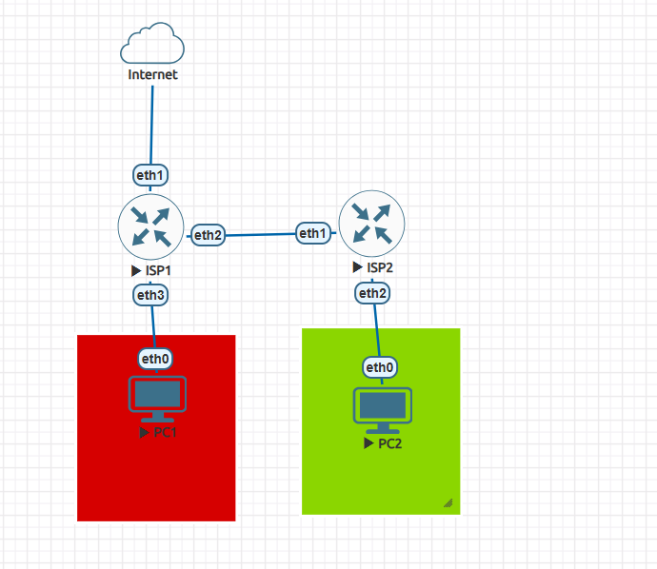

IP Address
CHR-1 | CHR-2 | PC1 | PC2
Ether1 : 192.168.133.103/24 | Ether 1 :  192.168.11.2/30 | 10.10.10.254/24 | 20.20.20.254/24
Ether 2 : 192.168.11.1/30 | Ether 2 :  20.20.20.1/24
Ether 3 :
10.10.10.1/24

Configure IP Address,NAT and DHCP Server in CHR-1 and CHR-2
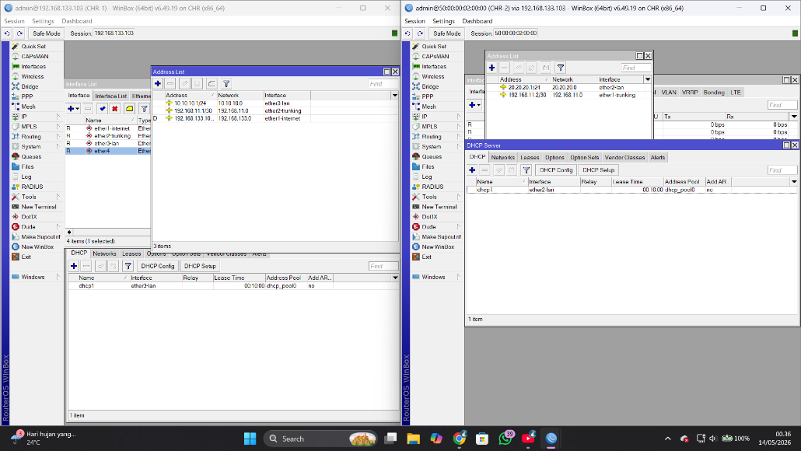
Configure OSPF in routing menu > OSPF
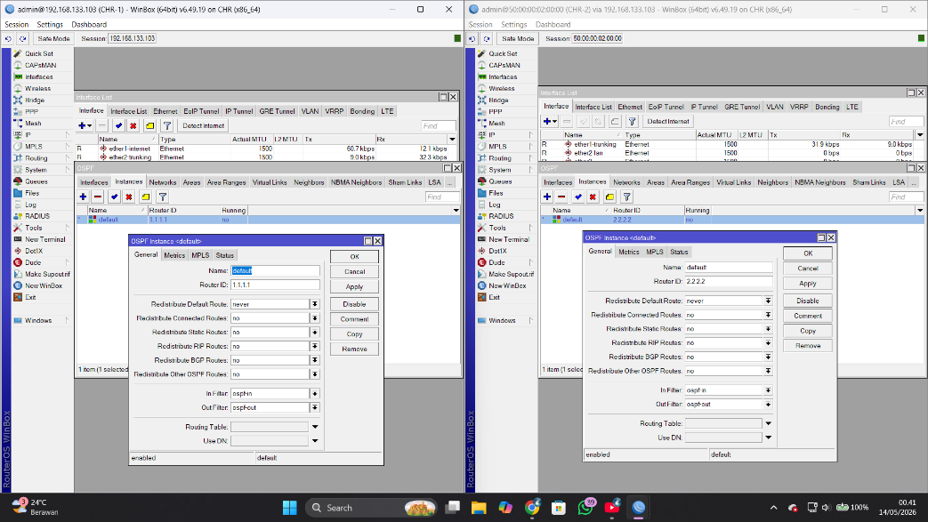
Configure router id for CHR-1 and CHR-2
CHR-1 = 1.1.1.1
CHR-2 = 2.2.2.2
The function of the router ID is as the router's identity, or when a neighbor is formed, the neighbor's router ID will appear.

Introduce local network to ospf in networks menu
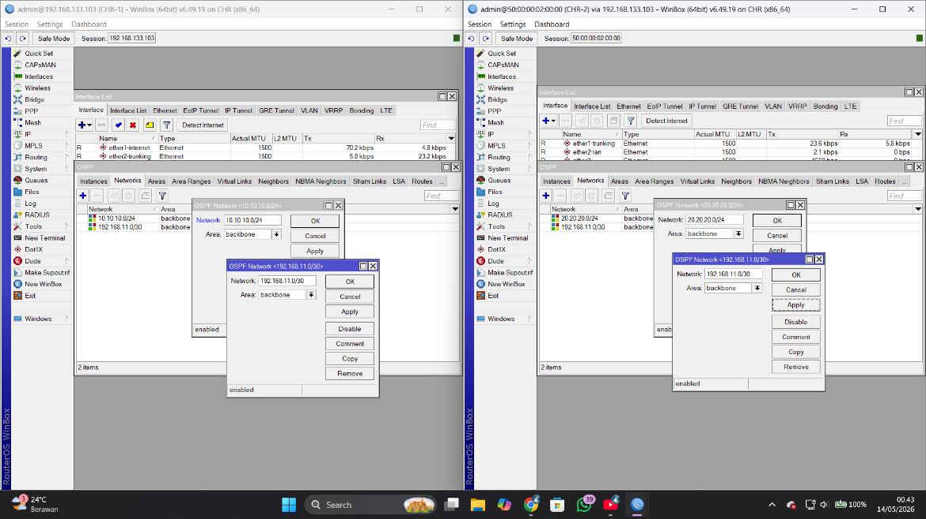
Add trunking Network and LAN Network in every router to OSPF, make sure to choose backbone as area so CHR-1 and CHR-2 in the same area, area 0
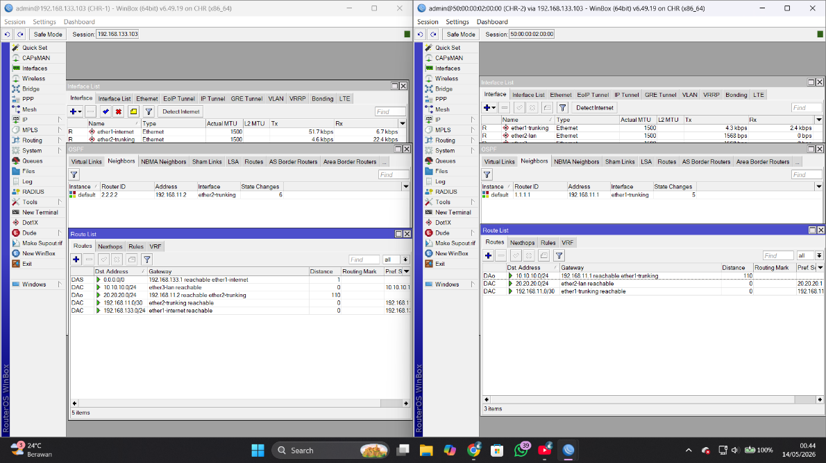
If your configure correct route OSPF will shows in routes menu

Test Client
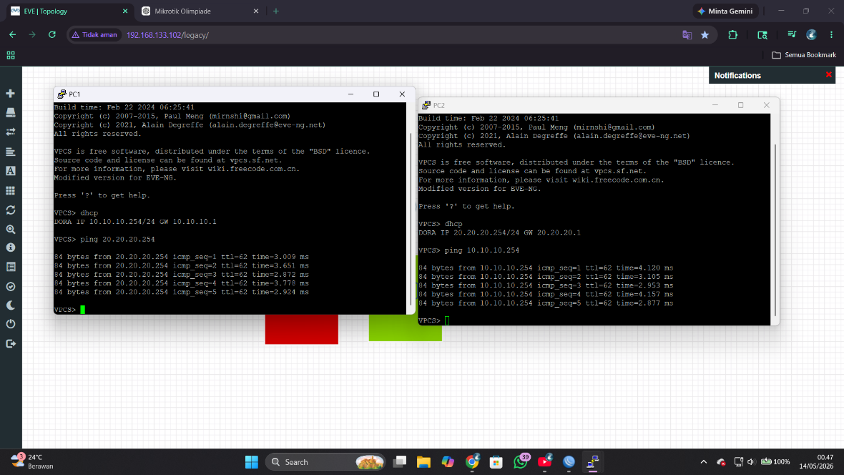
Passive Interface configuration
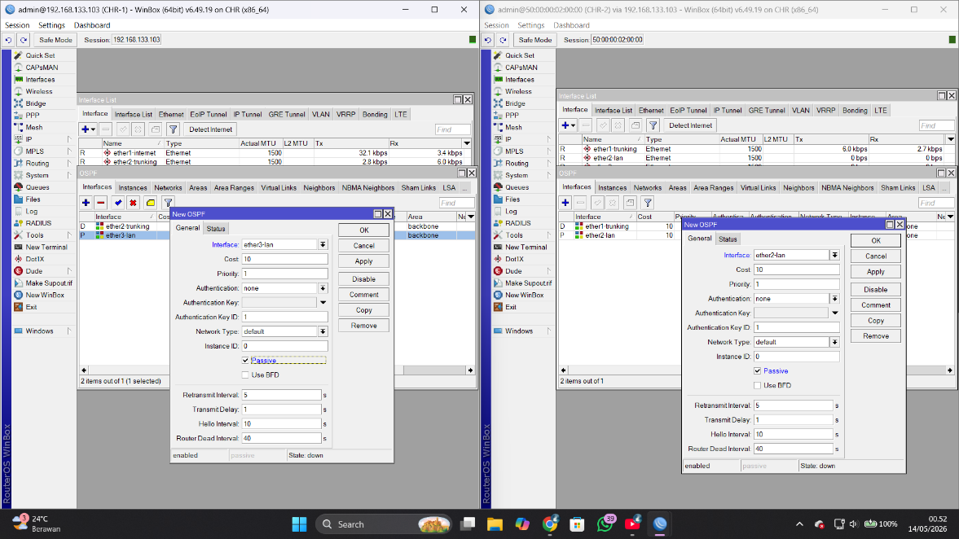
In interface as OSPF menu add new, choose interface which lead to LAN and tick passive interface and apply.
The function of the passive interface is so that OSPF not send hello packet to that interface, and save bandwith

Multi Area Topology
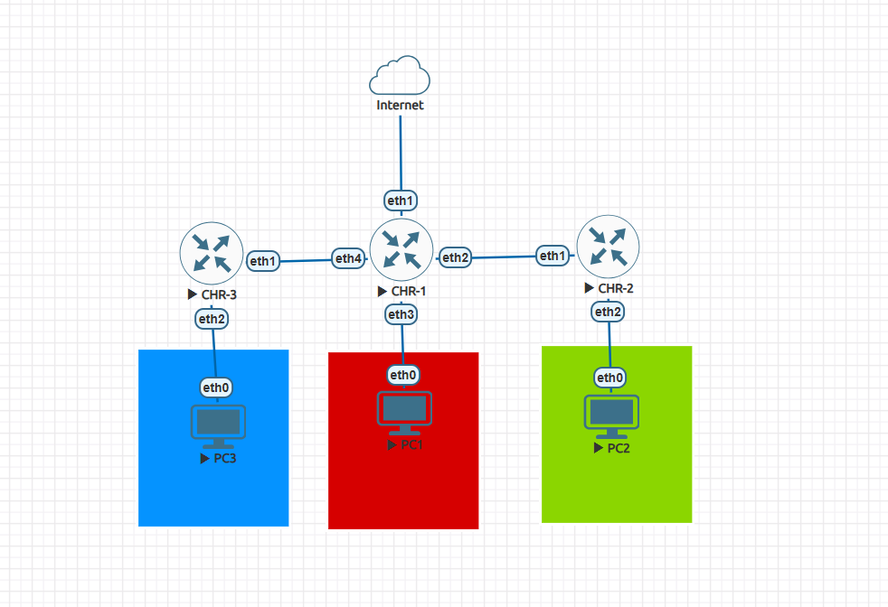
Add IP Address and DHCP Server to CHR-3
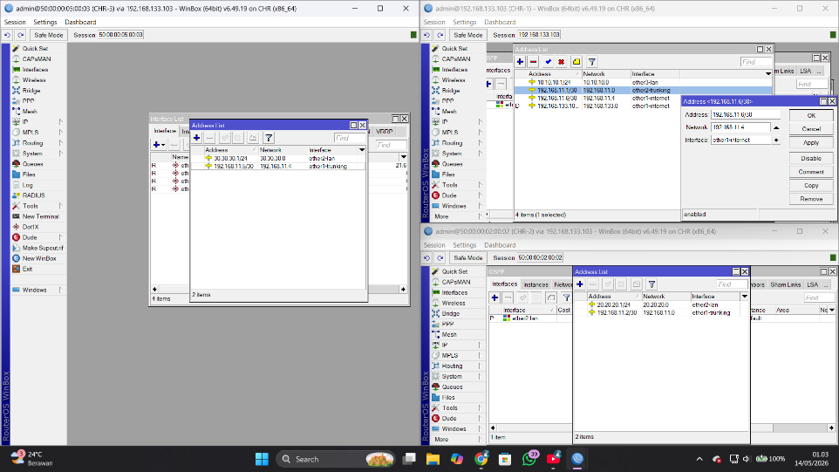
CHR-3
Trunking :
192.168.11.4/30
LAN :
30.30.30.0/24
Make new area in Routing > OSPF > Areas
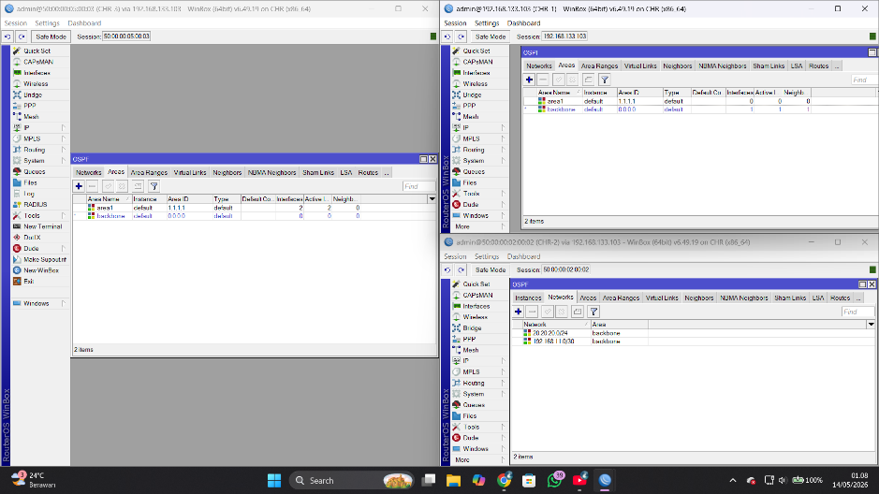
Fill it with 1.1.1.1 for area1 in CHR-1 and CHR-3
Configure Networks in OSPF
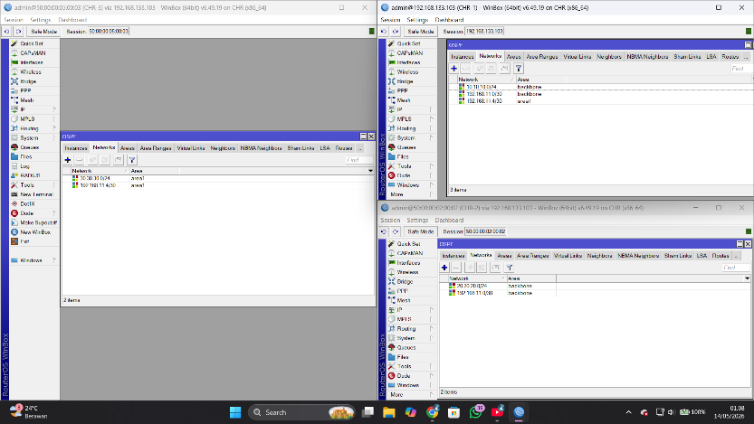
Make sure trunking interface set to area1
Test Client
